WHAT BRINGS US HERE+
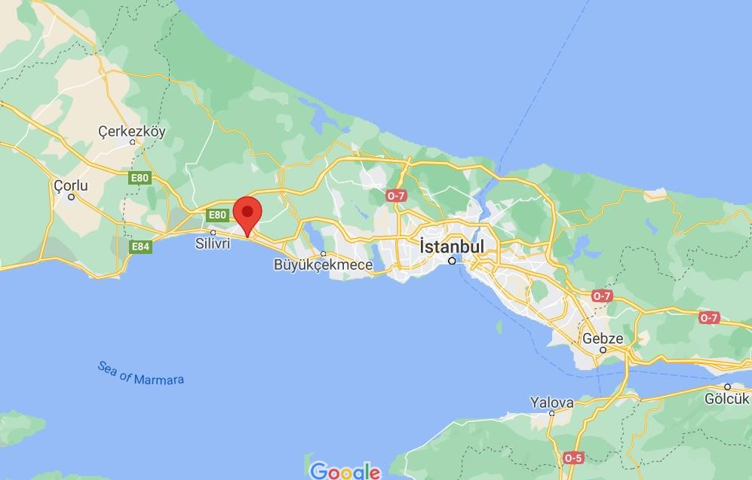
YOUTH EXCHANGE ISTANBUL, TURKEY
PLACE AND DATE: 1-11 JULY 2022, ISTANBUL, TURKEY
PARTICIPANTS: 60 people (8 youth + 2 group leaders from each country)
COUNTRY: Partner countries will be from Norway, Turkey, Romania, Lithuania, Poland and Croatia.
LANGUAGE: The working language will be English.

SUMMARY

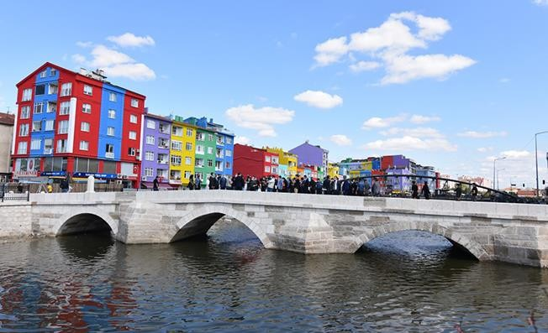
The SWOT analysis was done through an evaluation questionnaire of the youth needs, communities and partners, questionnaire with qualificatives and also with “box texts” for detailing the subjects needs. The questionnaire was applied at 240 youth from the local communities (40 from each partner).

Our team has outlined the 4 objectives thus they will be SMART, as follows:

- At the end of the project all 60 youth presents will feel themselves social included and non-discriminated. This will be reach through the activities of nonformal education such as Debate, Albatros and others during the 9 days of activities.

- At the end of the project all 60 youth will acquire new kwy competences through the nonformal education methods: public cafe, albatross, theatre and living library – increasing the self confidence and other activities during the 9 days of activities.

- At the end of mobility all 24 youth with few opportunities will feel themselves social integrated, will have trust in their own forces and will acquire new key competences which will help them in the active life. This will happen through the activities of public cafe, living library and other activities during the 9 days of activities.

- Throughout the project, we will develop a kind of tripartite cooperation between NGOs, youth and local authorities which

ACTIVITIES AND METHODS
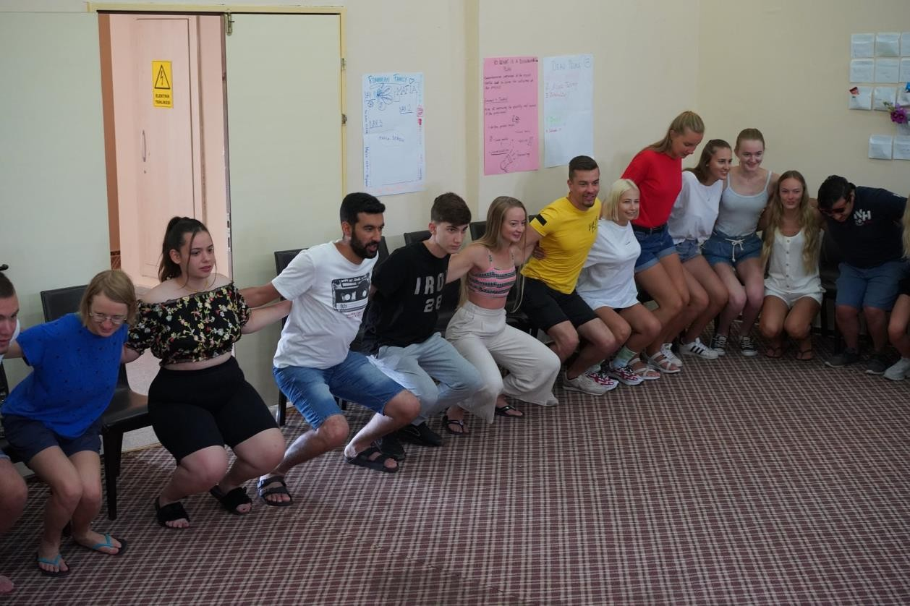
Working Methods

The methodology will be based on non-formal educational methods such as, practical exercises and opportunities for experiential learning. Thus, during the whole project methods will be used, such as interactive presentations, open discussions, role plays and various creative workshops including individual and group work.

Who can participate in the youth exchange?
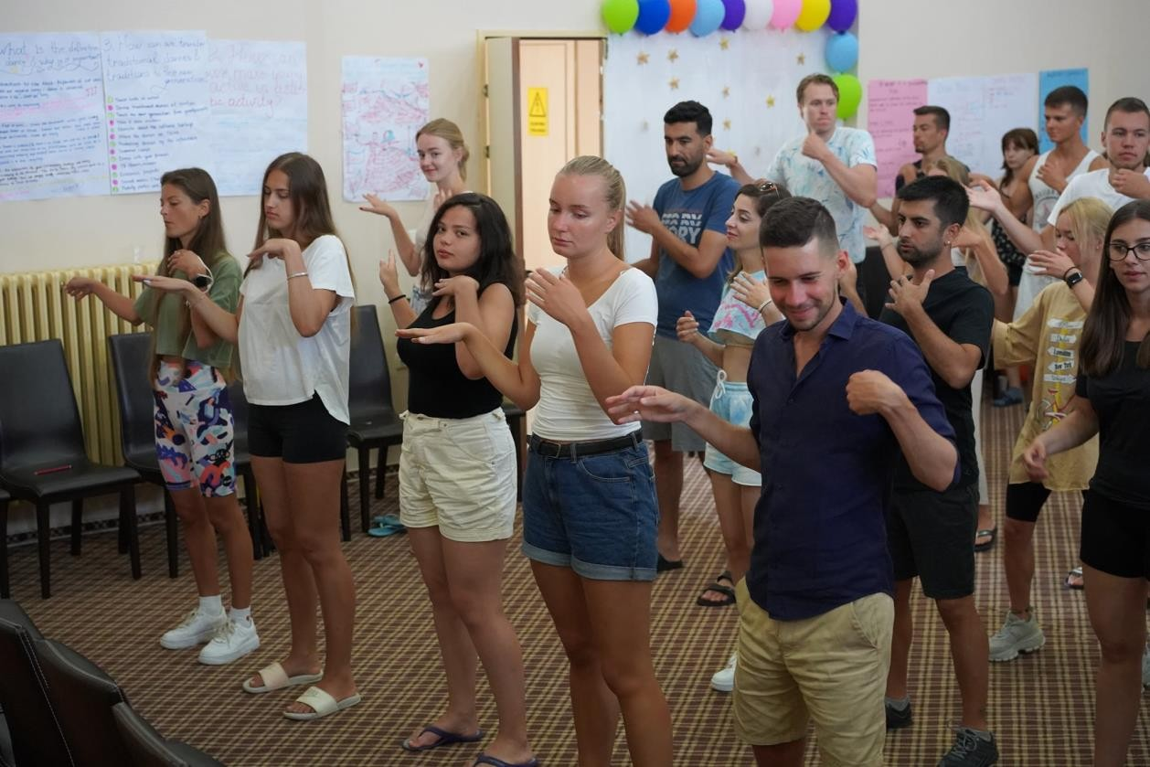
There will be 60 young people between 15 and 30 years of age, including one leader per group, 18+ and with no age limit, coming from 6 countries.
The project covers main activities: preparation, youth exchange in Turkey, evaluation and dissemination. PREPARATION FOR YE Basic elements of the preparation activities will be the preparation of already selected participants (preliminary list), arrangements for hosting and learning and dealing with logistics matters. Such international preparatory activities, as communication among partner organizations, discussion of the map of duties and agreements assigning responsibilities, providing informational materials and etc. will be made through on- line interaction (skype meetings and emails). However, preparatory meetings with participants on the project presentation, gender balance and safety rules and etc. will be held locally at partner institutions. Some preparatory tasks related to national cultural parties will be completed through team working and some tasks related to reading improvement of language and topic related skills will require individual preparation. Preparatory activities will involve all partners from all countries and will be made locally at their venues during planned dates.
Age of participants can be from 15 to 30 years old. Group leaders MUST be 18+.

THE VENUE
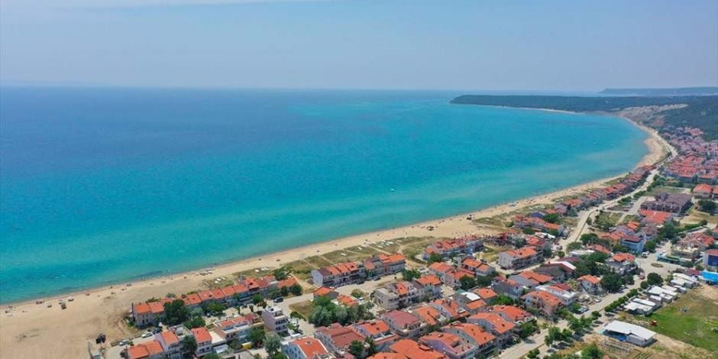
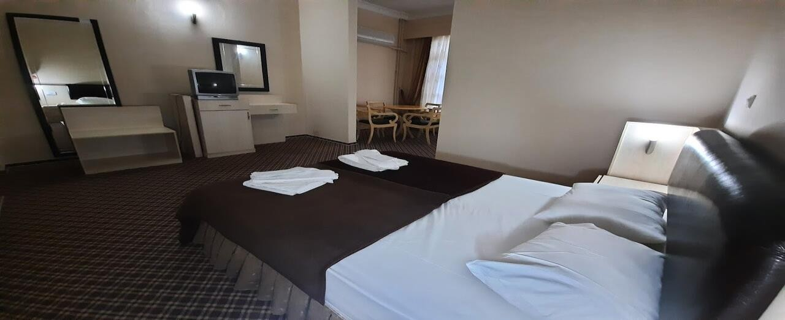

Note: Organisers will not provide accommodation for any additional stay in Turkey. If participants plan to arrive a few days earlier or depart a few days later, they are kindly requested to inform us and we will be glad to offer assistance with booking a hotel

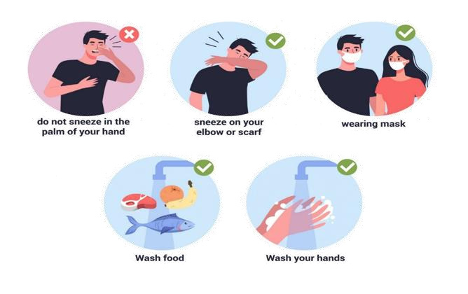
COVID-19 SPECIAL MEASURES ISTANBUL:

Beside the rules that we all know, and are respecting in our own countries, the following rules are necessary for the creation of a safe and productive learning environment:

- All persons coming to the youth exchange will need to take an RT-PCR test before the trip as it is mandatory to show a negative test upon entering Turkey. The costs related to the test are supported by the participant directly, if their country does not provide free testing. The list of acceptable tests is constantly being reviewed as government continues to seek the most accurate alternatives to the PCR test. If you cannot present the correct test result, you may not be allowed to board your flight. You are fully vaccinated; you are allowed to come to country without any PCR test.

- Before traveling, please ensure the rules to return home to your country. Will you need to be tested? Will you need to quarantine? If you need to test before returning home, this must be indicated on arrival so that testing can be scheduled within the specified time.

- All participants need to bring along face masks that you will use at all times in all common areas inside the accommodations. We will be using masks inside the activity room and other common areas. You will not need to wear the mask inside your sleeping rooms or outdoors, as long as you maintain proper physical distance. If it is not a reusable mask that you can wash every evening before going to bed, you should bring one mask for each working day. Additional disposable masks may be provided on site.

- Every bedroom, bathroom and common area will be equipped with disinfectant spray, disinfecting wipes and paper towels. The participants are responsible for disinfecting their room and the toilet inside the rooms. The youth center team will be disinfecting common

surfaces several times during the day.

- Before each session, the participants will need to wash their hands and use hand disinfectant that will be available at the entrance to the workshops room. The same procedure is necessary before each meal.

- We will have two non-contact digital thermometers. Every morning, group leaders will need to check the temperature of all participants from their team. If someone has a high temperature, the person will need to skip the morning session and self-isolate in the room arranged for these situations.

- After each session, facilitators will gather all materials (such as scissors, glue, markers etc.) that were used by participants and disinfect it for the next session.

- In order to avoid the use of many glasses during the day, all participants should bring one bottle from which they will be able to refill and drink water during the exchange. Disposable plates, cutlery and cups for coffee, tea or juice will be available.

- The breakfast, lunch and dinner will be served for each participant. We will explain the procedure to everyone after you arrive at the venue.

- Please note that the wearing of masks is mandatory in all public spaces in Turkey. This includes shops, restaurants, nightclubs and public transportation.

Our main priority is the safety of everyone, and we are sure that these rules and regulations will not stop us from having a good time and meeting amazing people from other countries. If anything is not clear to you or you have any questions, please feel free to contact us at any time.

ACCOMMODATION PLACE

Selimpaşa İMKB MTAL Uygulama Oteli

Photos and videos about our accommodation place and workshop place;
https://selimpasa.meb.k12.tr/icerikler/uygulama-oteli- iletisim_8114890.html

Rooms: Participants will be accommodated in 3 or 6 people each room. Bed linen and towels will be provided. The main activity room is located in the hotel. Wi-Fi internet connection is available. Organisers will provide participants with three meals per day. Food will be served.
We strongly recommend each participant to inform the organizers about any special dietary needs in advance.

HOW TO REACH THE HOTEL
Two weeks before the project, we will share info about how to reach the hotel on Facebook group.

More discussions can be done in Facebook group.

WHAT TO BRING
Since there is going to be an international evening, we will ask you to bring something traditional, famous or delicious from home - that you would like to represent your country with, and share with the others, it can be any kinds of food, drink...

HEALTH INSURANCE
Health insurance is not provided and will not be reimbursed by the organisers. All participants are strongly advised to purchase private travel insurance, as costs of private health care in Turkey are quite high if you don’t have.

The organizers will not provide the participants with any kind of insurance! Therefore, we
strongly recommend every participant to acquire travel insurance at their own expense for the whole duration of the course. Also, please have a valid EU healthcare insurance card (if applicable).

Each of the participating countries should;
  - Bring all your travel documents as presented above. Print out all your documents even if they are online. We don’t have printing opportunities.
  - Prepare a presentation about the sending organization (initiatives they have previously participated in, non-formal learning methods used, etc.). We want to get to know each other, to find out how people work with youth in other countries, and maybe to cooperate in the future.
  - Find interesting videos / games / exercises / educational activities on diversity.
  - Prepare energisers that could be done in the morning.
  - Prepare for your country’s cultural evening. Please, try to be fun and creative for this! :) No one likes regular .ppt presentations! Any kind of activities are welcome (e.g. video presentations, dances, songs, games, quizzes, posters, flyers etc.). Don’t forget to bring your national drinks, dishes or snacks to share with others. Also, please prepare a mini (and, of course, fun) language course for the others. We count on you to make these evenings as interactive and fun as possible.
  - check the weather forecast before arrival and bring adequate clothes. Please also bring clothing and shoes that can be used for strenuous activities (such as dancing).
Whenever possible, bring your laptops, digital cameras, smart phones and tablets – we will be doing some multimedia work that requires mobile equipment!

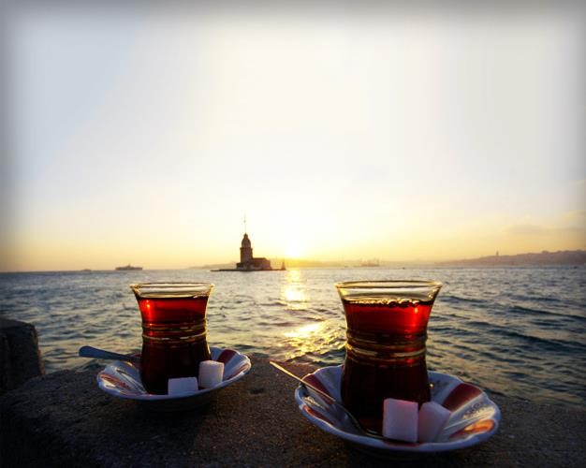

SEE YOU ALL IN ISTANBUL, TURKEY

