We are looking for participants for the following exciting Key Action 1: Training Course:
“SAFE project 2 - sexual safety standards in youth work” (SAFE 2)
Venue: Bystrzyckie Mountains, southern Poland (http://www.wataszka.com/)
A five day training will be held in Poland from 21st to 27th of October 2018.
(Travel days 21st and 27th of October 2018)
(funding approved) under the Erasmus+ youth programme
A Training Course for trainers, youth workers and peer leaders (especially working with youth with fewer opportunities). It is about creating sexual safety standards for youthwork!
Watch a short film from the last edition of the training: http://tkalnia.org/safe/
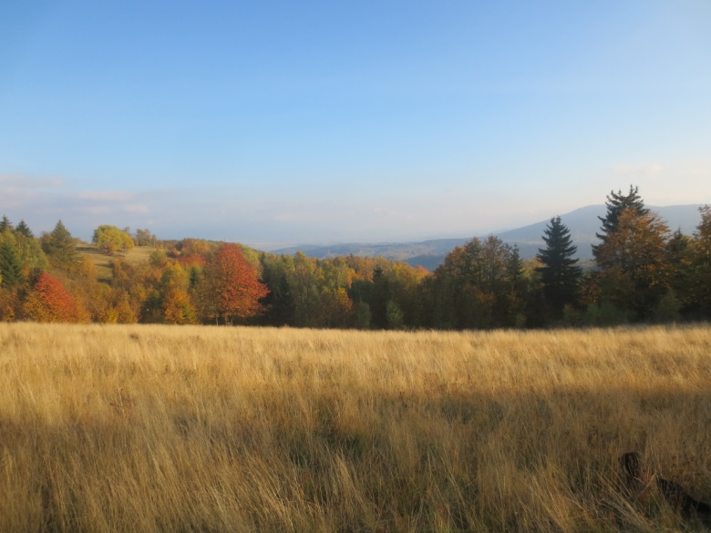

Description of the training

"SAFE project 2 - sexual safety standards in youth work" (SAFE2) is a continuation of activities devoted to issues of ensuring sexual safety in the context of youth work. Combining comprehensive sexual education, Wen-Do and anti-discrimination workshops and international experience on this issue, we want to create and promote a document that specifies the standards of sexual security in youth work.
The SAFE 2 project aims to provide young people with sexual safety during training, exchanges, and youth meetings in the context of knowledge, attitudes, awareness of existing stereotypes and discrimination.
During this training, we will work on:
- sex education standards and the way they are integrated into the professional practice of the participants.
- developing effective methods of combating discrimination.
- assertiveness and self-defense techniques developed as part of the Wen-Do methodology and how it can be integrated into the professional practice of the participants.
- creation of SAFE standards for each youth initiative and promotion of standards in the European countries.
- creating local and international projects with the participation of young people in the field sexual security.
- increasing knowledge about the possibilities of financing the Erasmus + Youth program.

The countries involved are Poland, Ireland, Nederland, Turkey, Russia, Spain, Greece and Lithuania. Number of participants and people involved: 26 (24 participants, 2 trainers).

Methods
Non-formal interactive methods include workshops on:
- Comprehensive sexual education
- Wen-Do techniques
- Anti-discrimination
- Drama exercises
- Warm-up, trust building, name learning
- Discussion, sharing, exchange of experience, movement & reflection.
The objectives of this course are:
- to learn more about the issues and challenges of sexual education in Europe
- to explore new approaches in empowerment
- to search for new way to eliminate discrimination through youth work
- to develop new educational projects focused on youth sexual safety
- to work on organizing local, national and international activities that address sexual safety standards
- to share this learning upon return to home countries
- to explore the Erasmus+ programme in greater detail.
- to provide a space for partnership building for future Erasmus+ projects.

Trainers

Kinga Karp – I'm an anti-discrimination trainer, WenDo trainer, psychologist and sexual educator associated with many social initiatives and non-governmental organizations active in the field of anti-discrimination and violence. Since 2005 I have been conducting workshops and trainings, recently mainly related to issues of discrimination and violence on grounds of sex and sexuality. At the beginning of 2016, I joined a group of people conducting workshops on self-defense and assertiveness for women and girls by the method WenDo - one of the most empowerment methods of counteracting violence that I know. I am a member of the board of the Anti-Discrimination Education Society. For several years I have been co-creating and implement international projects in the field of sharing good practices in counteracting homophobia. Together with the Foundation of Modern Education SPUNK I implement the Pregnancy and Sexually Transmitted Diseases Prevention Program in Łódź among Teenagers. We run a comprehensive and reliable sex education in junior high schools and educational institutions in Lodz.
Weronika Jóźwiak - holds a master’s in Cultural Anthropology, former educational specialist at Pinokio Theater in Łódź, anti-discrimination trainer, co-founder of Weaving Mill Association, polish NGO that supports anti-discrimination and civil education, creator of educational tools such as board games dedicated to financial and global education and book on gender roles. Sexual education trainer.
Profile of participants
We are looking for participans who work with young people, especially facing discrimination and who can integrate the learning into their practice and are interested and willing to initiate Erasmus+ projects. We would like to welcome preferably people with experience in sexual education, anti-discrimination, empowerment activities, willing to integrate and disseminate sexual safety standards in their home countries.

- Ready to cooperate in an Erasmus+ Project
- Ready for follow-up activities after the training
- Willing and able to communicate in English
- Only apply if you are excited, interested and willing to work hard at the training. You will be challenged to take risks and go deep into issues.
- Training available for participants from Greece, Ireland, Lithuania, Netherlands, Poland, Russia, Spain, Turkey

Travel

Participants need to get to Wrocław before 6 PM on 21st of October and depart from Wrocław after noon on 27th of October. You can also fly to Warsaw or Prague and then travel to Wrocław by train.
Travel from Wrocław to the venue and back is organized by Tkalnia (it takes around two hours!).

Lodging and food

Lodging and food is fully covered by organizers. We will be staying in lovely but rather raw mountain shelter Wataszka (wataszka.com). Rooms will be shared (from 3 to 9 beds!). Each room has a bathroom with warm water but it is limited and needs to be saved (no long baths). Food will only be vegetarian and vegan and very tasty.

When deciding to come on this training please bear in mind these
important points for all partners & participants:

- Training will take place in a rural location there is no shop, pub or amenities close by - ul. Górna 20, 57-500 WÓJTOWICE, (+48) 609 188 145
- All participants will be accommodated in shared bedrooms (from 3 to 9 beds!).
- Food will be only vegetarian and vegan.
- We will send more info about travel refund later. Please keep all original travel receipts for refund (bus, train plane). Try to fly in before 6 pm on 21st and after noon on 27th of October.
- Please only attend if you are a motivated participant and MUST be willing to dive head-in and participate FULLY in the training.
- Where possible please ensure a gender balance when selecting participants.
- All participants must be 18 years of age or over.
- All participants must be able to communication and work in English.
- Dogs are not welcome anymore But there are dogs and other animals there so please make sure you will inform us about allergies and phobias.
- Travel insurance is your responsibility – we strongly recommend that you take some travel insurance as we cannot refund tickets if you cannot travel for any reason.
- Please ensure you have your E111 – European health insurance number which you get free from your own country.
- Please bring a plug adapter for Poland.
- Please bring your own towel.
- October can be cold and rainy in Poland – bring waterproof clothes and walking shoes, it`s very beautiful there!

