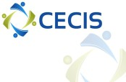

About the project

PLACE AND DATE: Tg-Jiu, 20 - 27.10.2019 (travel days included) 21-26.10.2019 (activity days)
PARTICIPANTS: 3 Youth workers from each partner country
LANGUAGE: The official language of the project is English

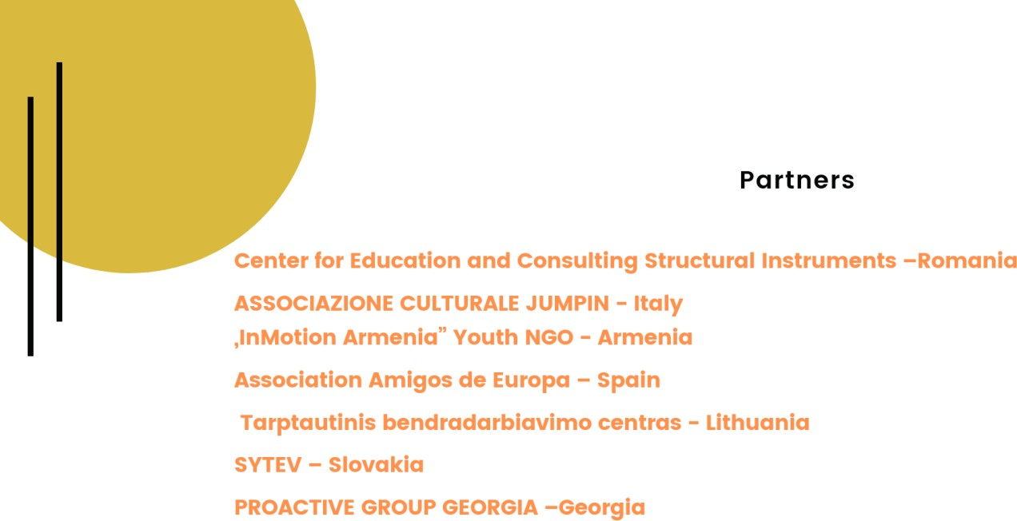

MAIN OBJECTIVE

- The project aims to train 21 youth workers from the partner countries in the field of entrepreneurial education through participation in a TC.

SPECIFIC OBJECTIVES:

- To support youth empowerment programs for disadvantaged youngsters from the partner countries and facilitate their entrance in the labor market, as employed or self-employed through development of a TC for 21 youth workers focused on the 4E - Employment - Employability – Entrepreneurship and Empowerment
- To facilitate peer-to-peer exchanges of ideas and best practices between 21 youth workers by exploring the meaning of youth empowerment & entrepreneurship and tools of working with disadvantaged youngsters

ACTIVITIES:

- The main project activity is a training course, which will connect our youth workers with 4 main concepts Employment - Employability - Entrepreneurship - Empowerment and will develop their abilities to empower disadvantaged young learners while making them aware and guide them to their employability prospects and career opportunities.
- The learning sessions will provide the participants with an understanding of empowerment and personal development concepts, assessment of youngsters’ needs, strengths and weaknesses and guidance through the development of their life skills.
- Develop youth workers capacities and knowledge in sustaining youngsters to establish a clear vision of their self, identifying areas to work on, to establish the level of priority for each area, ideas to get from where the person is for each skills or area, to where she/he wants to be.
- Explore the meaning of youth empowerment and entrepreneurship and tools to make it effective when working with youngsters with fewer opportunities
- The project is targeted to 21 youth workers from the partner organizations, working with disadvantaged youngsters and experience in entrepreneurial education whose main needs are related to difficulties in choosing appropriate methods to motivate and empower young people facing difficult situations, low levels of participation among vulnerable youngsters and difficulties faced to attract them to come into learning, teaching, training activities
- Improve poor knowledge of the 4 factors –empowerment – employment – employability - entrepreneurship and how to holistic approach youth unemployment and guide to self-employability or job employability their
young learners and the need to get international training and opportunity for exchanges, networks and partnerships with other youth organizations and youth workers to deliver quality youth services.

Learning outcomes

- Knowledge:
- Empowerment theory, types of empowerment, goals of empowerment, youth empowerment programs, youth personal development programs and approaches,
- Relationship between youth empowerment and entrepreneurship,
- Development of knowledge about entrepreneurial mind set and job employability,
- Assist disadvantaged youngsters through different tools.

Skills:
- Identify needs, strengths and weaknesses of different disadvantaged youth categories,
- Train youth on areas relevant for the current job market,
- Build and conduct development programs for capacity building and skills development of disadvantaged learners,
- Assist youth in developing self-determination and empowerment skills,
- Develop new training concepts.

Attitudes:
- Critical and well-founded understanding of multiple worldviews, experiences in youth education,
- Cooperation skills in international teams of trainers,
- Social perceptiveness and critical thinking,
- Cultural Competences - Diversity and inclusion.

Rules and principles of the mobility

- Answering the requirements of the sending and receiving organizations accordingly and respecting the deadlines for each task/activity
- Attendance at the TC and individual activities for the preparation and follow up.
- Following the set of rules of behavior inside the group during the mobility

Preparation of the participants for the mobility - Under the supervision and support of the sending organization and where needed receiving organization, each group of participants will:

- Participate in an informal workshop about the Erasmus + and will be guide to identify their learning objectives;
- Prepare a presentation of your organizations and your professional experience about working with young people
- Prepare an individual study about the TC topics and consultation of relevant documents about it and elaboration of a presentation of educational programs developed by your origin organizations in the field of the project topics as part of exchange and share sessions.
- Join the Facebook group of the project and participate at the discussions.
- Prepare together for the intercultural nights, which will be organized during the mobility: you are free to choose how to present your country, cultural symbols or tradition.
Follow-up

Youth Workers who participated in the TC commit to disseminate and share their learning experience inside their organization and in the local community. Returning home youth workers will create an educational program targeted to youngsters with fewer opportunities from the local community - it is predicted a number of 12 youngsters to participate in each partner organization. The programs will aim to empower participants and equip them with life skills, attitudes and behavior to be absorbed into the job market.
Instructions and relevant advice will be given during the TC

LOGISTICS:

TRANSPORTATION

Allocated budget for each participant/partner

Country | No. of participants | Price per participant | Total
Spain | 3 | 360 E | 1080 E
Georgia | 3 | 275 E | 825 E
Lithuania | 3 | 275 E | 825 E
Slovakia | 3 | 275 E | 825 E

Armenia | 3 | 275 E | 825 E
Italy | 3 | 275 E | 825 E

VISA

Country | No. of participants | Total
Armenia | 3 | 105 E

Reimbursement rules:

- ***Note – just 1 travel day is budgeted so the participants will seek to arrive on 20.10 in the evening and leave on 27.10 in the morning ( if informed in advance it is possible to leave on 26 in the evening, after the activities)
- The participants will present the travel itinerary to the organizer before purchasing the travel tickets to check compliance with distance band.
- The participants will receive the reimbursement after the mobility after all the documents have been received in original, through bank transfer only to the sending organizations.
- Each participant must present to the coordinator the travel documents in original: plane tickets, boarding passes, invoices, bus tickets, train tickets. It is preferable to have round trip tickets, if not possible each participant is committed to send the returning originals by post, after the mobility in maximum 10 days after the end of the mobility, at the following address: CECIS, str. 16 February, nr.8, bl.8, ap.2, Targu Jiu, Gorj, Romania.

IMPORTANT:

CECIS can organize a private transportation from/to the airport if the arrival/departure is at closed hours. We will collect from everybody the dates, so before planning the internal transfer, wait for our instructions.

Possible routes to get to Targu Jiu

The closest airport to Targu Jiu are in Bucharest – Henri Coanda International Airport http://www.bucharestairports.ro/ and Craiova - Craiova airport http://www.aeroportcraiova.ro/

From Bucharest Airport you can come to Targu Jiu by train or by bus:

- If you choose the train you need to get the train from the airport to Gara de Nord rail station, please access the following link to see the available trains and hours - Once you get to Gara de Nord, you need to take the train to Targu Jiu, here it is the link where you can see the offer: http://www.cfrcalatori.ro/en
- If you choose the bus you need to take the bus 783 until Piata Unirii 2 station, then take the subway from Piata Unirii 1 station to Pacii station. Once you get of the subway there is Autogara Militari where you can take the bus. Here it is the bus schedule:
http://www.autogari.ro/curse?pid=643&did=267&zi=2015-08-10&pas=1-0-0-0-0&lang=en
or http://www.cdyservice.ro/

!!! Some transportation cars need to make reservation in advance, so if you choose this option please inform us to make the reservations for you.

From Craiova Airport you can come by train or by bus

- If you choose the train, you need to take a taxi from the airport to Craiova railway station ( Gara Craiova). Here you can see the available trains: http://www.cfrcalatori.ro/en
- If you choose the bus you need to take a taxi from the airport to Autogara Craiova. Here you can see the available buses
http://www.autogari.ro/curse?pid=252&did=267&zi=2015-08-10&pas=1-0-0-0-0
!!! Some transportation cars need to make reservation in advance, so if you choose this option please inform us to make the reservations for you.

LOCAL TRANSPORTATION IN TG-JIU
- Buses – in Tg-Jiu there are regular buses that takes you to any poin of the city. The ticket price is 2 Ron ( one way).
- Taxi – price per km is 2 RON.

ACCOMMODATION

Details are to be provided as soon as possible

WHAT TO BRING:
- Intercultural night: some yummy food from your countries (candies or salty items) to be shared with the rest of the group. Please keep in mind to bring with you something already prepared as there is not the possibility to cook
- Travel insurance and European Health Card
- Medicines and insurance
- Your personal belongings
- Bring comfortable shoes and clothes.

CURRENCY EXCHANGE

The national currency in Romania is RON. 1 Euro = 4,7 RON. In Tg-Jiu you can find lots of money exchange shops and also ATMs. In most of the shops, you can pay by card.

CERTIFICATION
Every participants will receive a Certificate at the end of the project to document and recognize learning outcomes.

INTERCULTURAL NIGHT

The intercultural dimension of any international project it is very important, as it is a great opportunity for you to present your country, traditions and so on, but also your way to be, your lifestyle, your way to communicate, etc.
You can prepare an activity (games, thematic parties,) in which you will present your country, your national food and drinks, dances, etc. (if needed you can use the projector).
Since there is going to be an intercultural night, we ask you to bring something traditional, famous or delicious from home - that you would like to represent your country with, and share with the others, it can be any kinds of food, drink, costumes, music, etc.

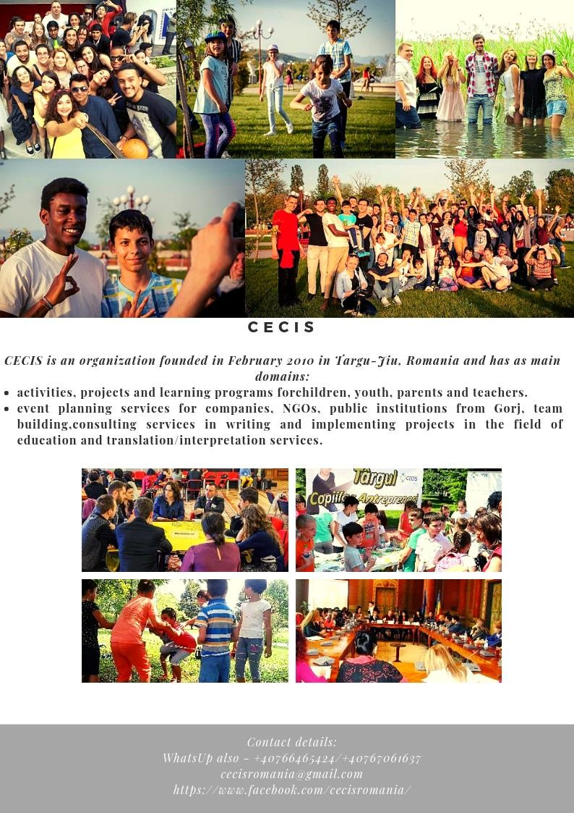

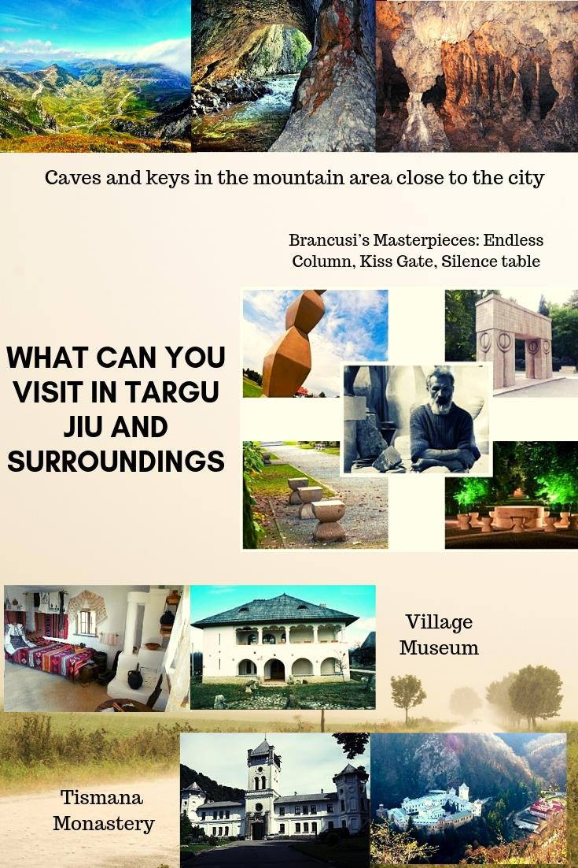

LOCATION:
CITY – TARGU JIU ( the city is located at about 300 km far from Bucharest – capital of Romania, at 4,5 hours by train/bus)
More about the city: http://cnipt-targujiu.ro/en/national-centre-for-tourism-information-and-promotion-targu-jiu/

Contact details:
+370 679 31214
info@wegoproject.lt

