Building Inclusive Society
Everyone Welcome
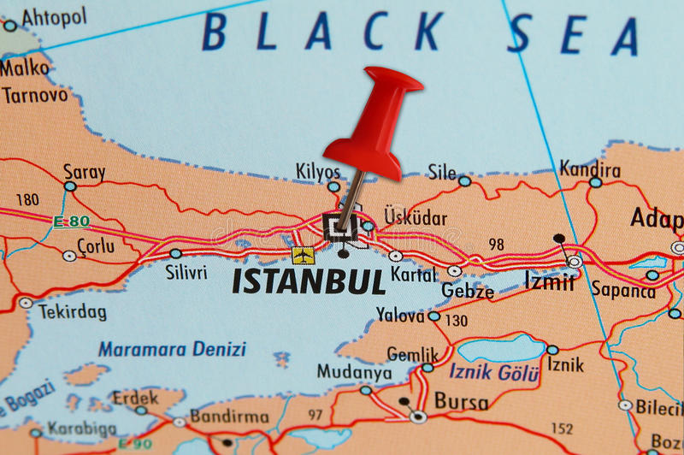

PLACE AND DATE FOR EXCHANGE: (11-19 September 2019) in Istanbul, Turkey
PARTICIPANTS: 60 young people (2 group leader + 8 participants from each countries)
WHO: 15-30
COUNTRY: Partner countries will be Norway, Turkey, Macedonia, Denmark, Lithuania and Czech Republic.
LANGUAGE: The working language will be English.

SUMMARY OF PROJECT
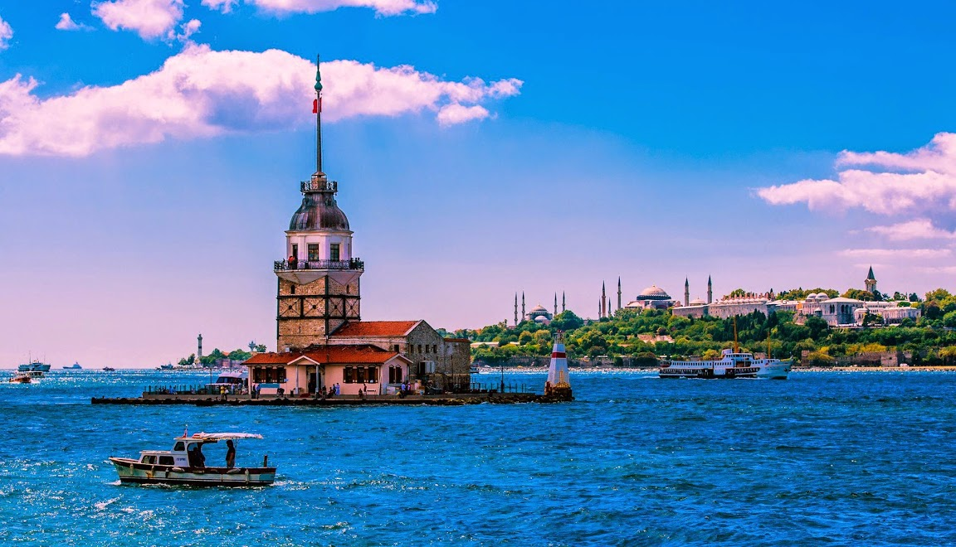
Youth Exchange ‘Building Inclusive Society: Everyone Welcome’ will be implemented in Istanbul, Turkey. It will bring together 60 young people from 6 different countries (Norway, Turkey, Macedonia, Denmark, Lithuania and Czech Republic.).
By reaching below mentioned objectives youth exchange ‘Building Inclusive Society: Everyone Welcome’ will contribute to creating gender equal societies and it will lead to gender empowerment of young people in participating countries.
Objectives of youth exchange ‘Building Inclusive Society: Everyone Welcome’:
1. To provide the participants an opportunity to reflect on own gender identity and the perception of society towards different genders;
2. To increase knowledge of the participants on gender equality and mechanisms leading to creating gender equal societies;
3. To raise awareness of young people reached through blog, social networks and YouTube channel on gender, gender discrimination and role of young people in the process of creating gender equal society
4. To open the question of gender discrimination with special focus to be paid young people representing LGBTQ;
5. To develop competencies of the participants needed to address gender based stereotypes, prejudices and discrimination, especially through social networks and events in their communities;
6. To increase knowledge of the participants on Erasmus + Programme and to encourage the participants to take part in youth mobility.
This youth exchange will be with Programme Countries. Youth exchange ‘Building Inclusive Society: Everyone Welcome’ will include 60 participants representing following countries: Norway, Turkey, Macedonia, Denmark, Lithuania and Czech Republic …
Youth exchange ‘Building Inclusive Society: Everyone Welcome’ will include as newcomers as young people who already took part in mobility activities. Working language of the youth exchange will be English, and participants will have basic knowledge of English (common language), motivation to improve their communication skills and gain new competences they can use in their lives. Participants also need to have interest in gender, fighting gender discrimination, exploring gender realities in participant’s countries, in Erasmus + Programme, and working on new project ideas.

ACTIVITIES AND METHODS
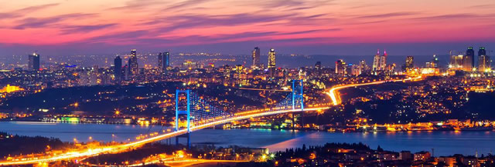
Working methods Youth exchange ‘Building Inclusive Society: Everyone Welcome’ will be based on different non-formal learning methods and techniques: getting to know techniques and methods to create open and supportive environment and break the barriers between the participants; discussion on the importance of gender equality, presentations of gender realities in participant’s countries, comparing the realities and identifying the roots of gender discrimination, simulation with aim to gain better understanding of the consequences of gender discrimination, especially discrimination of LGBTQ and the role of young people in the process of addressing it, work in mix-intercultural teams on posts containing information about gender being spread through social networks with aim raise interest of young people in gender, gender issues. Each day the participants will be meeting in their national teams and reflect on the project. After meetings in national teams group leaders will meet and discuss the feedback from the participants. Besides meetings in national teams the participants will have an opportunity to reflect on development of their competencies and strengthen their knowledge about the role and use of YouthPass. At the end of the project, each participant will receive YouthPass as recognition of their learning results.
During the project days the group leaders will support active involvement of young people in the project activities because it is significantly important for development of young people skills and competencies e.g. young people will implemented some of the activities - energizers, ice-breakers, discussion, they will deliver presentations. We are convinced that direct involvement of young people is significantly important for creating feeling of ownership over the project and it is motivating young people to stay active also after the project is finished.

PARTNERS
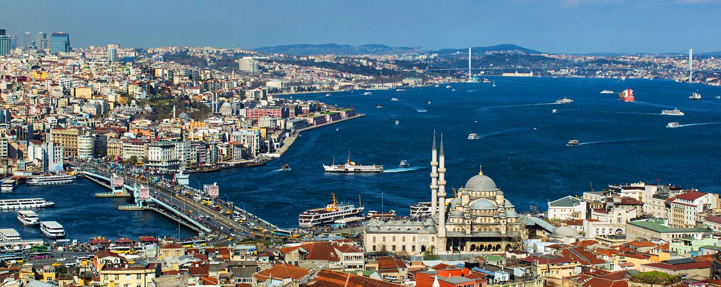
The project will host participants from the following 6 countries;
The partners are from Norway, Turkey, Republic of Macedonia, Czech Rep. Denmark and Lithuania.

TRAVEL COSTS
According to new Erasmus Plus rules, the reimbursement of travel costs will be calculated used a specific program called Distance Calculator:
Country of Origin | Country of  Destination | Distance Band | No. of  Participants | Travel Grant per  Participant
Norway | Istanbul, TR | 2000-2999 km | 10 | 360.00
Czech Republic | Istanbul, TR | 500-1999 km | 10 | 275.00
Denmark | Istanbul, TR | 500-1999 km | 10 | 275.00
Lithuania | Istanbul, TR | 500-1999 km | 10 | 275.00
Macedonia | Istanbul, TR | 500-1999 km | 10 | 275.00

After sending their tickets and boarding cards, participants will receive reimbursement of their travel costs. Travel expenses (flights and other means of transport) are compensated (up to 100%) based on the actual expenses incurred and the distance from your location of residence to the location of the project (Istanbul, Turkey). These distances must be calculated using the distance calculator supported by the European Commission. We will not send money to each participants. We will send money to the sender organisations which in turn will reimburse the participants.
Accommodation, living and other project-related expenses: 100% funded by the EU. Visa fees are to be covered by participants.
Please note any extra days you wish to stay will be your own responsibility and food etc.

DON’T ASK TO LEAVE PROJECT ONE DAY EARLY TO CATCH YOUR FLIGHT OR BUS. PLEASE BUY YOUR TICKETS ACCORDING TO THE PROJECT DATES.

THE VENUE
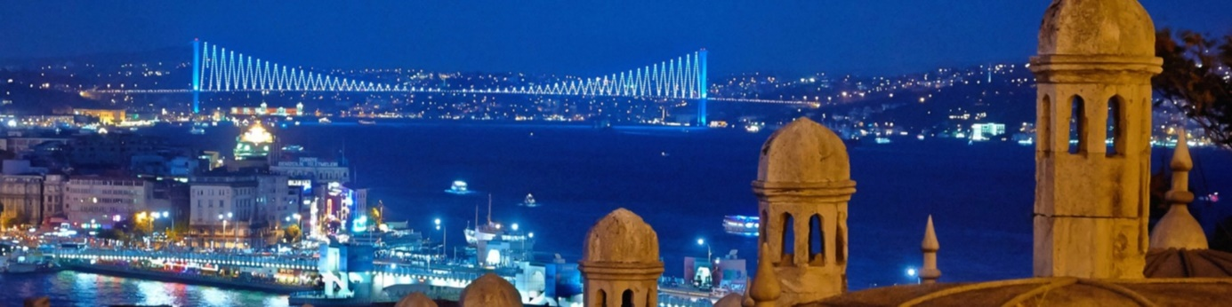
Istanbul (Turkish: İstanbul)), once known as Constantinople and Byzantium before that, is the most populous city in Turkey, and the country's economic, cultural, and historical center. Istanbul is a transcontinental city in Eurasia, straddling the Bosphorus strait between the Sea of Marmara and the Black Sea. Its commercial and historical center lies on the European side and about a third of its population lives on the Asian side. The city is the administrative center of the Istanbul Metropolitan Municipality (coterminous with Istanbul Province), both hosting a population of around 14 million residents. Istanbul is one of the world's most populous cities and ranks as world's 5th-largest city proper and the largest European city.
Note: Organisers will not provide accommodation for any additional stay in Istanbul. If participants plan to arrive a few days earlier or depart a few days later, they are kindly requested to inform us and we will be glad to offer assistance with booking a hotel. 2 days before project or 2 days after project only allowed. This is no holiday, so please respect the Erasmus+ projects rules.

THE VENUE
Legend Otel TEM
Metro Turizm Tesisleri Selimpasa Istanbul (51.75 km)
34570 Istanbul, Turkey
(0212) 734 21 11
https://www.facebook.com/legendoteltem

HOW TO REACH THE HOTEL
We can pick you up from airport. We can collect all participants in one place and take big bus to hotel (if you want us to pick you up). If you want to come yourself, You can take tramway/metro from airport to Yenibosna station. From Yenibosna station you can take bus to Selimpasa. When you come to Selimpasa, we will pick you up infront of MIGROS store.
Remember that travel costs from the airport to the hotel is part of your total travel budget. We can pick you up from airport if you want, but each participants must pay for travel costs.

ARRIVAL
When you come to the hotel, you will find your name and room number at the reception desk.
There will be 2-4-6 persons per room.
We cannot arrange special room for couples. COUPLES ARE NOT WELCOME TO THIS PROJECT.
Breakfast, lunch and dinner will be served in the hotel.
You do DO NOT NEED to bring your own towels. Note that the special events are not included in accommodation facilities. If you want to take a sauna or enjoy the spa, you will have to pay from your own pocket.
SMOKING AND ALCHOL ARE TOTAL FORBIDDEN IN OUR PROJECTS! LETS ENJOY AND HAVE FUN WITHOUT ALCHOL AND SMOKING! LETS BE A GOOD EXAMPLE FOR OUR OTHERS AND CREATE GREEN AND HEALTHY ENVIRONMENT!

WHAT TO BRING
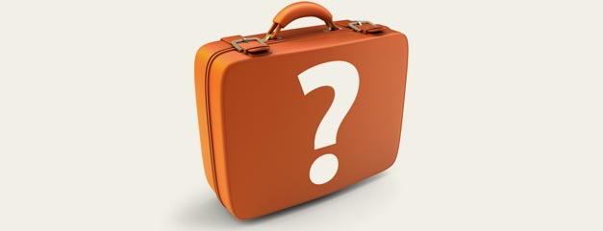
Since there is going to be an international evening, we will ask you to bring something traditional, famous or delicious from home. Something that you would like to represent your country with, and share with the others, it can be any kinds of food, drink etc.
Check the weather forecast and be prepared for all kinds of weather.

HEALTH INSURANCE
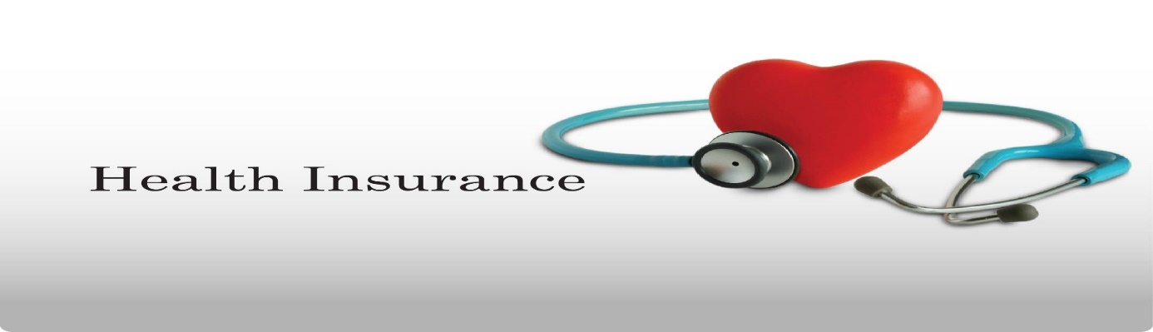
Health insurance is not provided and will not be reimbursed by the organisers. All participants are strongly advised to purchase private travel insurance, as the cost of private health care in Turkey is quite high if you do not have insurance.

PREPARATION
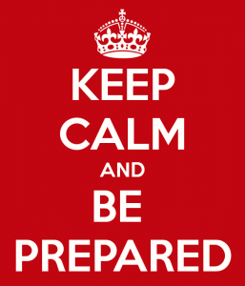

The organizers will not provide the participants with any kind of insurance! Therefore, we strongly recommend every participant to acquire travel insurance at their own expense for the whole duration of the course. Also, please have a valid EU healthcare insurance card (if applicable).

Each of the participating countries should;
- Bring all your travel documents as presented above. Print out all your documents even if they are online. We don’t have printing opportunities.

- Prepare a presentation about the sending organization (initiatives they have previously participated in, non-formal learning methods used, etc.). We want to get to know each other, to find out how people work with youth in other countries, and maybe to cooperate in the future.
- Prepare a presentation on diversity in their country.
- Find interesting videos / games / exercises / educational activities on diversity.
- Prepare energisers that could be done in the morning.
- Prepare for your country’s cultural evening. Please, try to be fun and creative for this! :) No one likes regular .ppt presentations! Any kind of activities are welcome (e.g. video presentations, dances, songs, games, quizzes, posters, flyers etc.). Don’t forget to bring your national drinks, dishes or snacks to share with others. Also, please prepare a mini (and, of course, fun) language course for the others. We count on you to make these evenings as interactive and fun as possible.
- check the weather forecast before arrival and bring adequate clothes. Please also bring clothing and shoes that can be used for strenuous activities (such as dancing).
- Bring good spirit, joy and happiness!!!
Whenever possible, bring your laptops, digital cameras, smart phones and tablets – we will be doing some multimedia work that requires mobile equipment!

BASIC RULES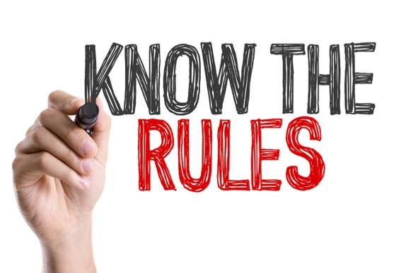
All participants are expected to be present and active in all the activities, unless they are ill.
Unauthorized absence from the activities and workshops will not be tolerated.
IF YOU ARE LATE ALL TIME AND DON’T OBEY THE RULES, YOU WILL BE SENT HOME.
Smoking is prohibited everywhere inside buildings, thus all the smokers will have to go outside or to specially designated areas for a cigarette.
ALCOHOL IS FORBIDDEN in our projects.
Stress, nerves and bad mood is prohibited everywhere.
Bring your best mood and big smile with you and keep it through the exchange!
Prepare for fun! Those who fail to do that will be expelled from the exchange.

OUR PARTNERS MUST PROVIDE;

- Full Police checks for staff who are working with organisation and those who are participating youth exchange.
- Partner Organisations’ Policies relating to Child Protection, Data Protection and Health and Safety.
- If you have participants under the 18 years old, participants must provide “Parental Consent form”.

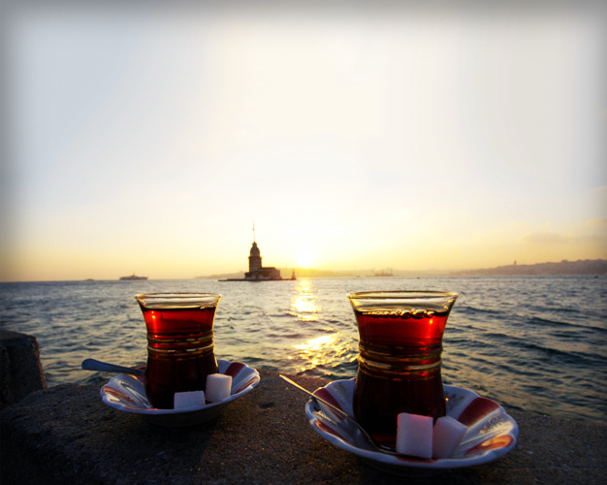

SEE YOU ALL IN ISTANBUL, TURKEY

