IDENTITY

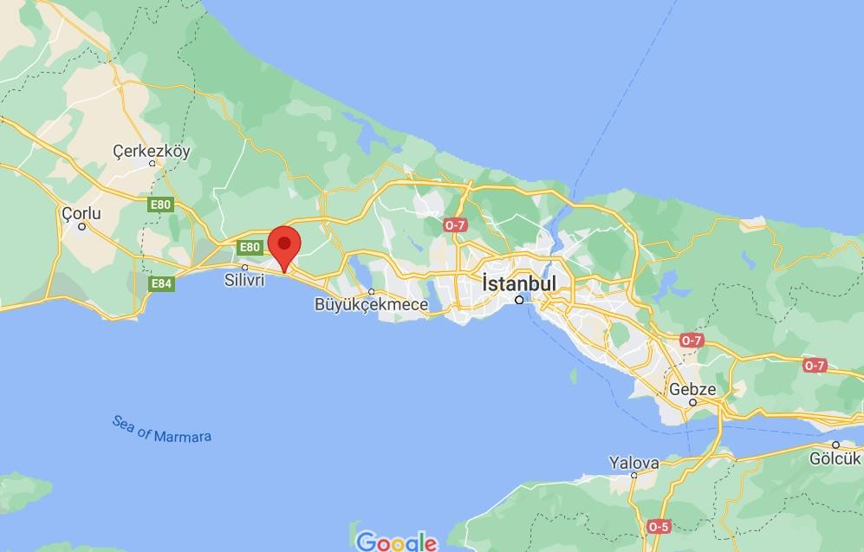
YOUTH EXCHANGE ISTANBUL, TURKEY
PLACE AND DATE: (22-30 June 2020) to ISTANBUL, Turkey
PARTICIPANTS: 60 people (8 youth + 2 group leaders from each country)
COUNTRY: Partner countries will be from UK, Denmark, Turkey, Lithuania, Macedonia and Slovakia.
LANGUAGE: The working language will be English.

SUMMARY

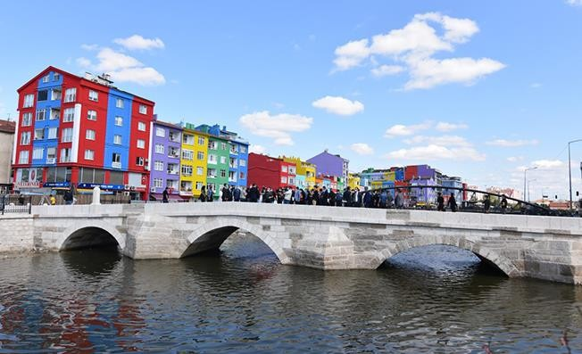
We set following objectives of youth exchange “Identity”:

-to increase knowledge of the participants on gender equality and mechanisms leading to creating gender equal societies;
-to provide the participants an opportunity to reflect on own gender identity and the perception of society towards different genders;
-to open the question of gender discrimination with special focus to be paid young people representing LGBTQ;
-to develop competencies of the participants needed to address gender based stereotypes, prejudices and discrimination, especially through social networks and events in their communities;
-to raise awareness of young people reached through blog, social networks and YouTube channel on gender, gender discrimination and role of young people in the process of creating gender equal society
-to increase knowledge of the participants on Erasmus + Programme and to encourage the participants to take part in youth mobility.

ACTIVITIES AND METHODS
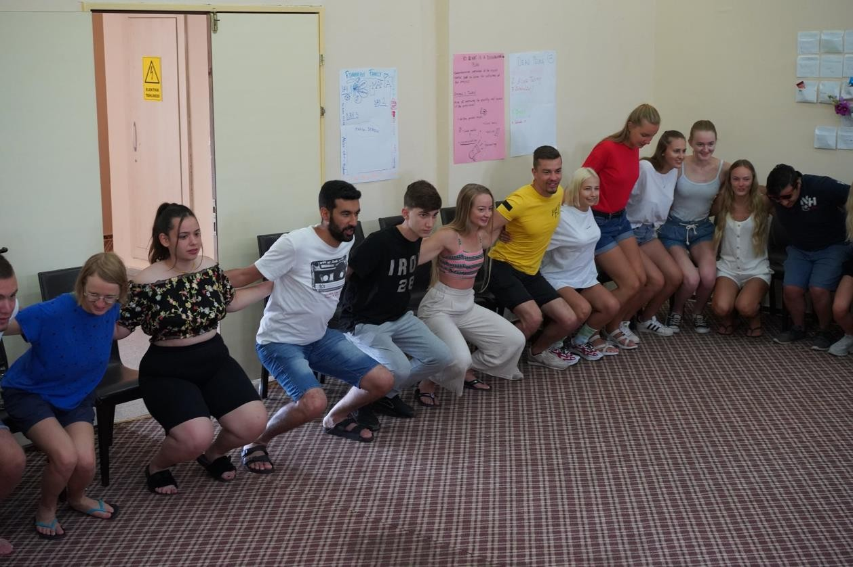
Working Methods

Youth exchange “Identity” will be based on different non-formal learning methods and techniques: getting to know techniques and methods to create open and supportive environment and break the barriers between the participants; discussion on the importance of gender equality, presentations of gender realities in participant’s countries, comparing the realities and identifying the roots of gender discrimination, simulation with aim to gain better understanding of the consequences of gender discrimination, especially discrimination of LGBTQ and the role of young people in the process of addressing it, work in mix- intercultural teams on posts containing information about gender being spread through social networks with aim raise interest of young people in gender, gender issues. Each day the participants will be meeting in their national teams and reflect on the project. After meetings in national teams group leaders will meet and discuss the feedback from the participants.
Besides meetings in national teams the participants will have an opportunity to reflect on development of their competencies and strengthen their knowledge about the role and use of YouthPass. At the end of the project, each participant will receive YouthPass as recognition of their learning results.

Who can participate in the youth exchange?
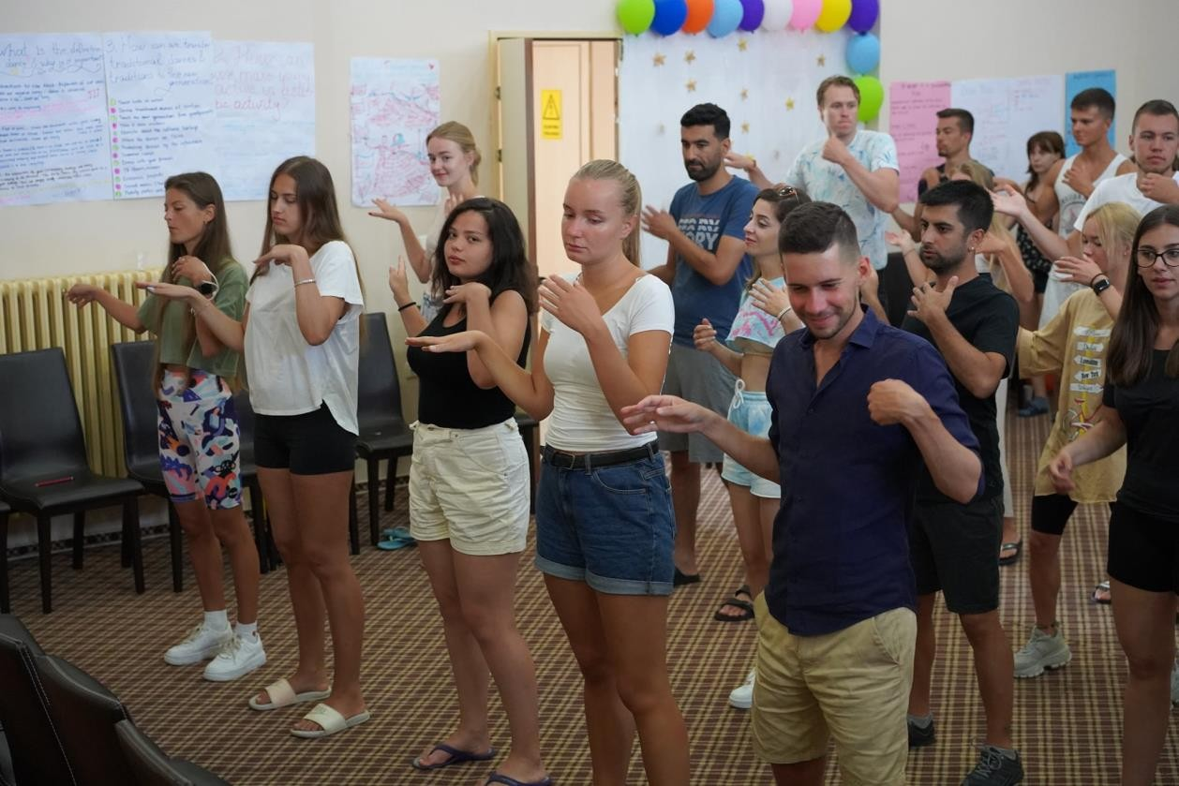
There will be 60 young people between 15 and 30 years of age, including one leader per group, 18+ and with no age limit, coming from 6 countries.
Young people coming from participating organizations were actively involved in the process of preparation of this project application. They came up with the project idea. They had possibility to comment on the project draft, proposed programme, to share their ideas for activities, topics covered by the project. By direct involving young people in the process of preparation of the project application the partners aim to ensure that the project is responding on the needs of young people – to learn more about hate speech, discrimination, social exclusion, to better understand the roots of these issues, to be aware of the consequences, to have knowledge of tools, activities that can be used to increase awareness of young people in this area, to learn about human libraries, to develop competencies useful in the future e.g. in job seeking process, looking for mobility opportunity.

Age of participants can be from 15 to 30 years old. Group leaders MUST be 18+.

THE VENUE
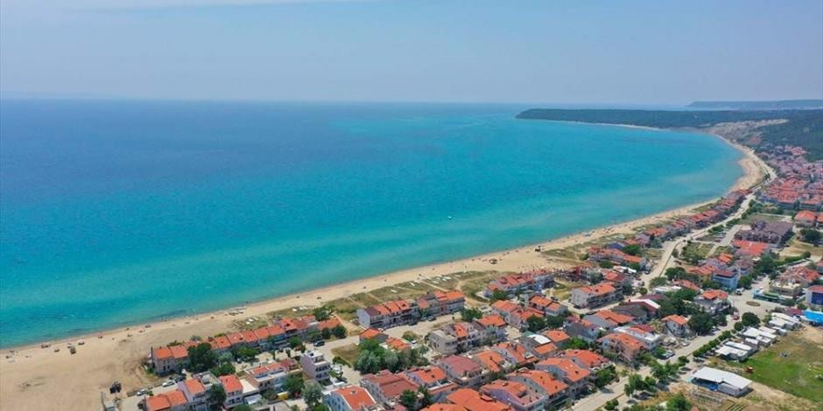
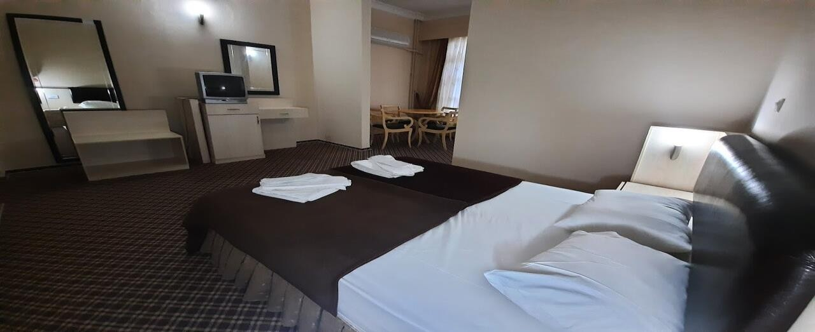

Note: Organisers will not provide accommodation for any additional stay in Turkey. If participants plan to arrive a few days earlier or depart a few days later, they are kindly requested to inform us and we will be glad to offer assistance with booking a hotel

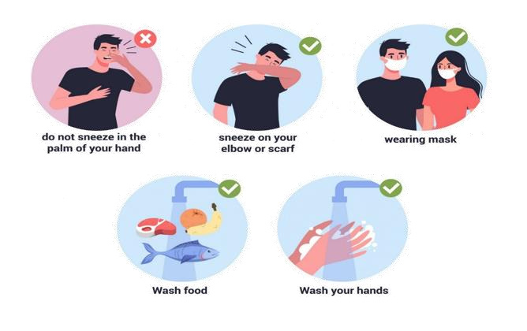
COVID-19 SPECIAL MEASURES ISTANBUL:

Beside the rules that we all know, and are respecting in our own countries, the following rules are necessary for the creation of a safe and productive learning environment:

- All persons coming to the youth exchange will need to take an RT-PCR test before the trip as it is mandatory to show a negative test upon entering Turkey. The costs related to the test are supported by the participant directly, if their country does not provide free testing. The list of acceptable tests is constantly being reviewed as government continues to seek the most accurate alternatives to the PCR test. If you cannot present the correct test result, you may not be allowed to board your flight. You are fully vaccinated; you are allowed to come to country without any PCR test.

- Before traveling, please ensure the rules to return home to your country. Will you need to be tested? Will you need to quarantine? If you need to test before returning home, this must be indicated on arrival so that testing can be scheduled within the specified time.

- All participants need to bring along face masks that you will use at all times in all common areas inside the accommodations. We will be using masks inside the activity room and other common areas. You will not need to wear the mask inside your sleeping rooms or outdoors, as long as you maintain proper physical distance. If it is not a reusable mask that you can wash every evening before going to bed, you should bring one mask for each working day. Additional disposable masks may be provided on site.

- Every bedroom, bathroom and common area will be equipped with disinfectant spray, disinfecting wipes and paper towels. The participants are responsible for disinfecting their room and the toilet inside the rooms. The youth center team will be disinfecting common

surfaces several times during the day.

- Before each session, the participants will need to wash their hands and use hand disinfectant that will be available at the entrance to the workshops room. The same procedure is necessary before each meal.

- We will have two non-contact digital thermometers. Every morning, group leaders will need to check the temperature of all participants from their team. If someone has a high temperature, the person will need to skip the morning session and self-isolate in the room arranged for these situations.

- After each session, facilitators will gather all materials (such as scissors, glue, markers etc.) that were used by participants and disinfect it for the next session.

- In order to avoid the use of many glasses during the day, all participants should bring one bottle from which they will be able to refill and drink water during the exchange. Disposable plates, cutlery and cups for coffee, tea or juice will be available.

- The breakfast, lunch and dinner will be served for each participant. We will explain the procedure to everyone after you arrive at the venue.

- Please note that the wearing of masks is mandatory in all public spaces in Turkey. This includes shops, restaurants, nightclubs and public transportation.

Our main priority is the safety of everyone, and we are sure that these rules and regulations will not stop us from having a good time and meeting amazing people from other countries. If anything is not clear to you or you have any questions, please feel free to contact us at any time.

ACCOMMODATION PLACE

Selimpaşa İMKB MTAL Uygulama Oteli

Photos and videos about our accommodation place and workshop place;
https://selimpasa.meb.k12.tr/icerikler/uygulama-oteli- iletisim_8114890.html

Rooms: Participants will be accommodated in 3 or 6 people each room. Bed linen and towels will be provided. The main activity room is located in the hotel. Wi-Fi internet connection is available. Organisers will provide participants with three meals per day. Food will be served.
We strongly recommend each participant to inform the organizers about any special dietary needs in advance.

HOW TO REACH THE HOTEL
Two weeks before the project, we will share info about how to reach the hotel on Facebook group.

More discussions can be done in Facebook group.

WHAT TO BRING
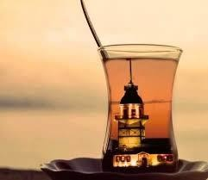
Since there is going to be an international evening, we will ask you to bring something traditional, famous or delicious from home - that you would like to represent your country with, and share with the others, it can be any kinds of food, drink...

HEALTH INSURANCE
Health insurance is not provided and will not be reimbursed by the organisers. All participants are strongly advised to purchase private travel insurance, as costs of private health care in Turkey are quite high if you don’t have.

The organizers will not provide the participants with any kind of insurance! Therefore, we
strongly recommend every participant to acquire travel insurance at their own expense for the whole duration of the course. Also, please have a valid EU healthcare insurance card (if applicable).

Each of the participating countries should;
  - Bring all your travel documents as presented above. Print out all your documents even if they are online. We don’t have printing opportunities.
  - Prepare a presentation about the sending organization (initiatives they have previously participated in, non-formal learning methods used, etc.). We want to get to know each other, to find out how people work with youth in other countries, and maybe to cooperate in the future.
  - Find interesting videos / games / exercises / educational activities on diversity.
  - Prepare energisers that could be done in the morning.
  - Prepare for your country’s cultural evening. Please, try to be fun and creative for this! :) No one likes regular .ppt presentations! Any kind of activities are welcome (e.g. video presentations, dances, songs, games, quizzes, posters, flyers etc.). Don’t forget to bring your national drinks, dishes or snacks to share with others. Also, please prepare a mini (and, of course, fun) language course for the others. We count on you to make these evenings as interactive and fun as possible.
  - check the weather forecast before arrival and bring adequate clothes. Please also bring clothing and shoes that can be used for strenuous activities (such as dancing).
Whenever possible, bring your laptops, digital cameras, smart phones and tablets – we will be doing some multimedia work that requires mobile equipment!

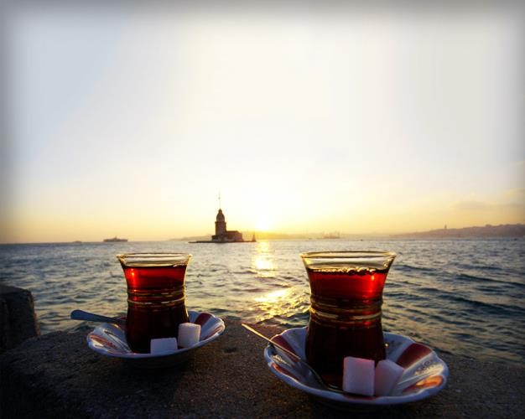

SEE YOU ALL IN ISTANBUL, TURKEY

