Human Library: Human Rights Education in Practice
Type of Activity: Youth Exchange
PLACE AND DATE: (1-9 July 2019) to Hindholm, Fuglebjerg DENMARK.
PARTICIPANTS: 60 young people (8 youth + 2 group leaders from each country).
COUNTRY: Partner countries will be from United Kingdom, Denmark, Turkey, Lithuania, Italy and Republic of Macedonia.
LANGUAGE: The working language will be English.
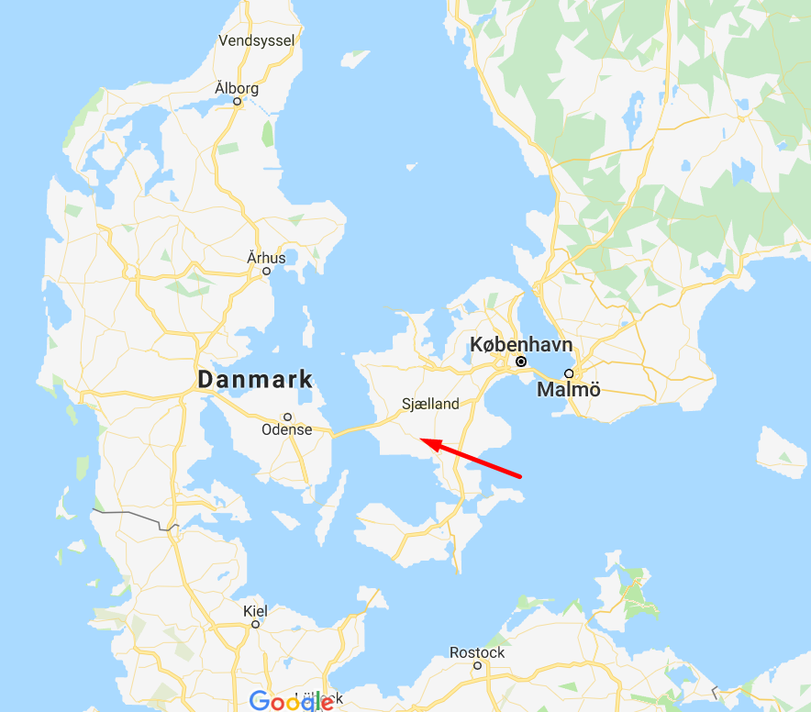
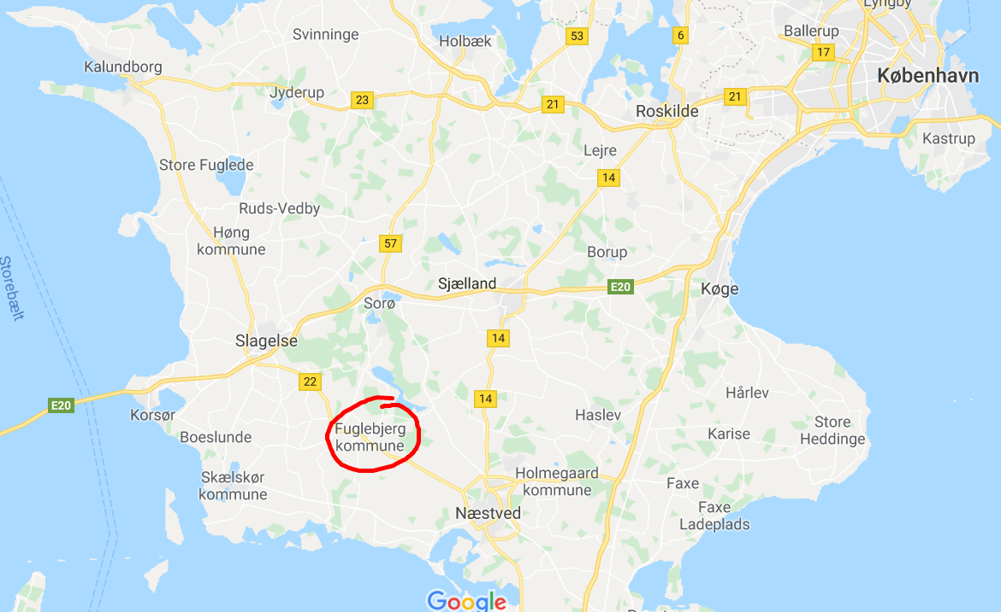

SUMMARY OF PROJECT
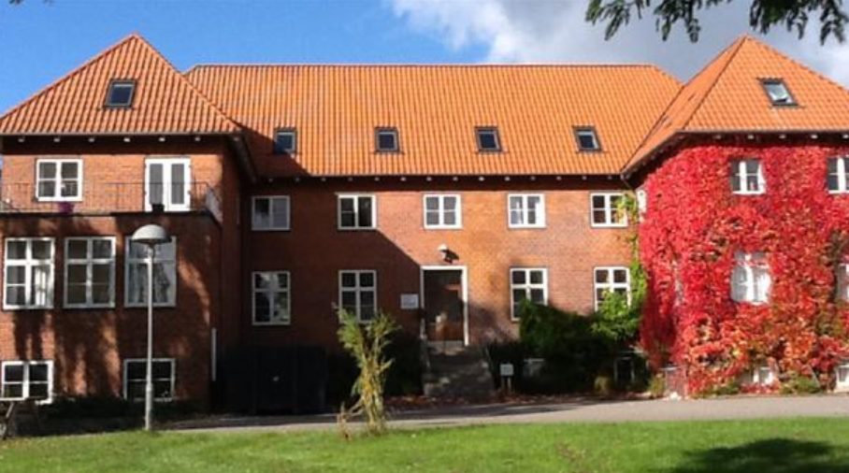
Youth exchange “Human Library: Human Rights Education in Practice” responds on the need to address social exclusion, discrimination and hate speech in participating countries. Through the youth exchange the participants will not just develop gain new knowledge on social exclusion, discrimination but moreover they will strengthen their skills to realize ‘human library’ event in their communities and directly contribute to process of creating socially inclusive society.
Objectives of youth exchange:
a) To develop participant’s competencies in the area of human rights education and the methodology of human libraries;
b) to raise participant’s knowledge on the process of realization of human library as a way of addressing stereotypes, prejudices and fighting discrimination;
c) to empower the participants to contribute to creating socially inclusive society through the process of organizing ‘human library’ during the youth exchange;
e) to develop participants competences such as teamwork, leadership, communication, presentation and to contribute to their personal and professional development;
f) to raise intercultural competencies of the participants by giving them an opportunity to interact and work with young people coming from different European countries and also local community from the hosting country;
g) to raise knowledge of the participants about Erasmus + Programme and its Key Action 1 and to encourage the participants to take active part in the Programme.
h) to support creating network and partnerships between participating organizations, exchange of good practices among participating countries related to human rights education, social inclusion.
By meeting all above mentioned objectives the youth exchange will contribute to achieving goals of Europe 2020 strategy and Erasmus + Programme.

ACTIVITIES AND METHODS
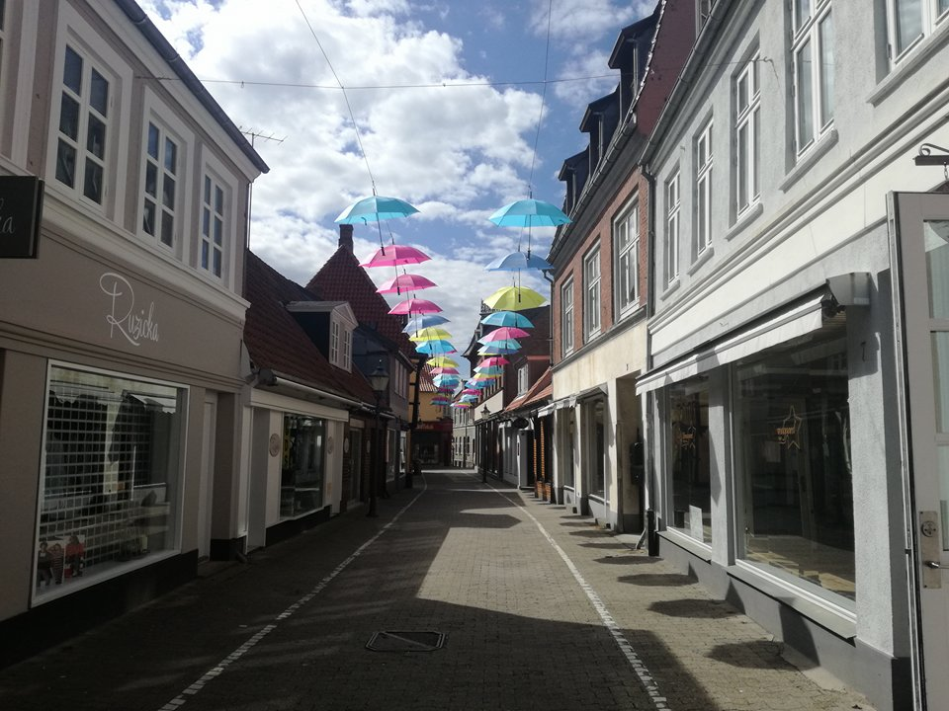
Set project objectives will be meet through activities based on variety of non-formal learning methods and techniques including discussions, debates, role plays, simulations, reflection activities, individual challenges, and group work in intercultural team. The activities will be tailored to the needs and interests of the participants, young people including young people with fewer opportunities, in age between 18 to 30 years.
The youth exchange will have impact on several levels. On individual level it will contribute to development of competencies of the participants in the areas of social exclusion, discrimination and hate speech. The participants will gain new knowledge but also they will develop their competencies to realize ‘human library’ in their communities. The youth exchange will also have impact on the participating organizations. The organizations will benefit from new practices, possibility of networking and working on ideas for future projects fighting discrimination, social exclusion and hate speech. Moreover, the youth exchange will have impact on local communities of participating countries because ‘visitors’ coming from these communities will have chance to participate in future ‘human libraries’ and contribute to building socially inclusive society.
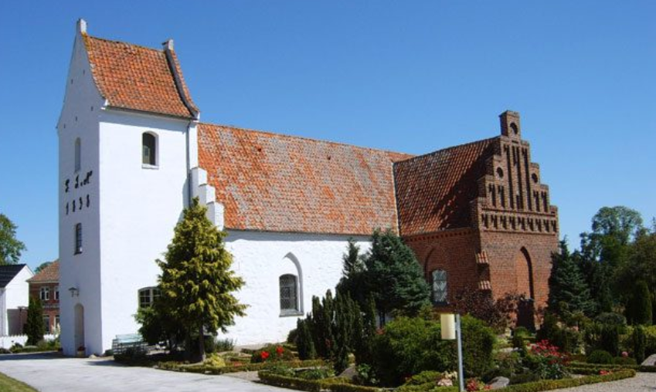
TRAVEL COSTS
According to new Erasmus Plus rules, the reimbursement of travel costs will be calculated used a specific program called Distance Calculator:
Type of Activity: YOUTH EXCHANGE;
Country of Origin | Country of  Destination | Distance Band | No. of  Participants | Travel Grant per  Participant
Macedonia | Denmark | 500 - 1999 km | 10 | 275.00
Italy | Denmark | 500 - 1999 km | 10 | 275.00
Lithuania | Denmark | 500 - 1999 km | 10 | 275.00
Turkey | Denmark | 500 - 1999 km | 10 | 275.00
United Kingdom | Denmark | 500 - 1999 km | 10 | 275.00
After sending their tickets and boarding cards, participants will receive the reimbursement of their travel costs. Travel (flights, other means of transport) expenses are compensated (up to 100%), based on the actual expenses incurred and the distance from your location of residence to the location of the project (Fuglebjerg, Denmark). These distances must be calculated using the distance calculator supported by the European Commission. We don’t send money to each participants. We send only money to sender organization and sender organization will pay to participants.

IMPORTANT!
Our organization didn’t receive all the money from National Agency. That’s why the travel costs will be done after approval final report. We will send final report 1st of November. Usually it takes 45 days to get answer!
Please do not ask for any money before approval of final report.
Please note any extra days you wish to stay will be your own responsibility and food etc.
Visa costs will be covered by participants.
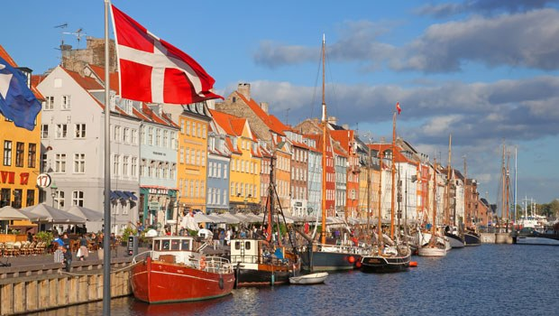
VENUE 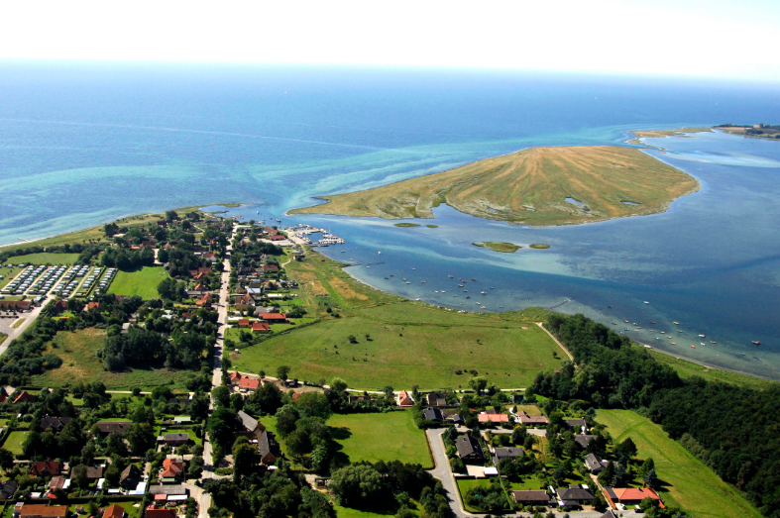
Note: Organisers will not provide any accommodation for additional stay in Denmark. If participants plan to arrive a few days earlier or depart a few days later they are kindly requested to inform us and we will be glad to offer assistance with booking a hotel.
Mina Hindholm Efterskole
Hindholmvej 19, 4250 Fuglebjerg, Danmark

HOW TO REACH FUGLEBJERG
HOW TO REACH FUGLEBJERG
There can be two alternatives. First we can pick up all participants at the same time from Copenhagen city senter or you can come to project place by yourself.

1.Flight is the easiest way to come to Copenhagen.
2.Take train from CPH Airport to Sorø St.
3. Take Bus from Sorø St. to Lundevej (Fuglebjerg)
4. We will pick you up from Lundevej (Fuglebjerg) busstation.
Follow this link please; https://www.rome2rio.com/map/Copenhagen-Airport-CPH/Fuglebjerg
If you have any difficulties with coming to Nysted, please contact us.

ACCOMODATION
Mina Hindholm Efterskole
Hindholmvej 19, 4250 Fuglebjerg, Danmark

There are going to be 2-4-6-8 persons per room. We can’t arrange special room for couples.
Participants MUST prepare and make breakfast, lunch and dinner.
3 meals per day, plus coffee and snacks made by the participants in coordinated international work groups. Tasks will be divided between participants and everybody MUST obey the rules.
VERY IMPORTANT!
The place is belong to government and it is total alcohol forbidden in the place and during the project.

HEALTH INSURANCE
Health insurance is not provided and will not be reimbursed by the organisers. All participants are strongly advised to purchase private travel insurance, as costs of private health care in DENMARK are quite high if you don’t have.

PREPARATION

The organizers will not provide the participants with any kind of insurance! Therefore, we strongly recommend every participant to acquire travel insurance at their own expense for the whole duration of the course. Also, please have a valid EU healthcare insurance card (if applicable).

Each of the participating countries should;
- Bring all your travel documents as presented above. Print out all your documents even if they are online. DO NOT FORGET TO TAKE WITH YOU!

- Prepare a presentation about the sending organization (initiatives they have previously participated in, non-formal learning methods used, etc.). We want to get to know each other, to find out how people work with youth in other countries, and maybe to cooperate in the future.
- Prepare a presentation on diversity in their country.
- Find interesting videos / games / exercises / educational activities on diversity.
- Prepare energisers that could be done in the morning.
- Prepare for your country’s cultural evening. Please, try to be fun and creative for this! :) No one likes regular .ppt presentations! Any kind of activities are welcome (e.g. video presentations, dances, songs, games, quizzes, posters, flyers etc.). Don’t forget to bring your national dishes or snacks to share with others. Also, please prepare a mini (and, of course, fun) language course for the others. We count on you to make these evenings as interactive and fun as possible.
- check the weather forecast before arrival and bring adequate clothes. Please also bring clothing and shoes that can be used for strenuous activities (such as dancing).
- Bring good spirit, joy and happiness!!!
Wherever possible, take your laptops, digital cameras, smart phones and tablets – we will be doing some multimedia work that requires mobile equipment!

BASIC RULES
Smoking is prohibited everywhere inside buildings; thus all the smokers will have to go outside or to specially designated areas for a cigarette.
Alcohol is TOTAL forbidden inside building and garden of accommodation place.
Bring your best mood and big smile with you and keep it through the exchange!
Prepare for fun!
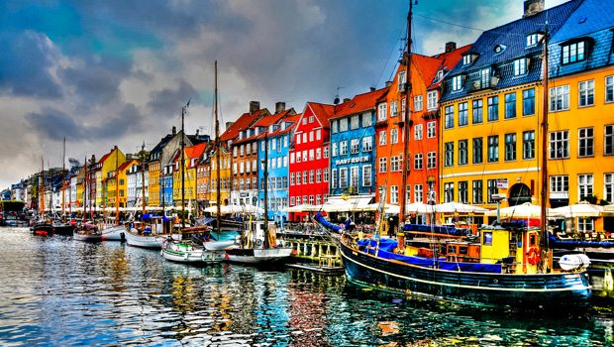

SEE YOU ALL IN FUGLEBJERG, DENMARK

