CLIMATE AMBASSADOR
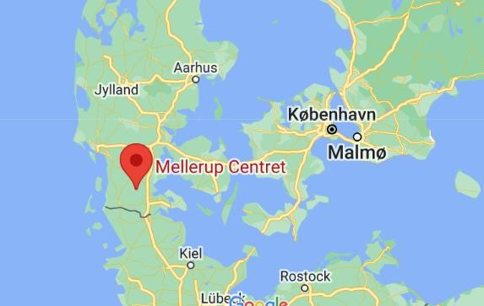
YOUTH EXCHANGE AGERSKOV, DENMARK
PLACE AND DATE: 17-27 JUNE 2022, AGERSKOV, DENMARK
PARTICIPANTS: 60 people (10 youth + 2 group leaders from each country)
COUNTRY: Denmark, UK, Lithuania, Slovakia and Turkey.
LANGUAGE: The working language will be English.

SUMMARY

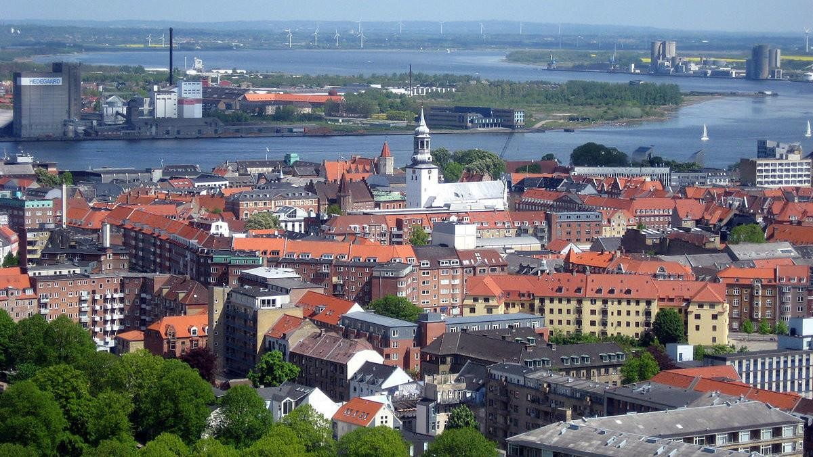
Our project is called “Climate Ambassador” and its main aim is to show the importance of environmental protection in small communities by the young participants through creative campaigns made using methods of non-formal education and through concrete actions to reduce the negative impact caused by man to nature. Also, we want a better communication and to create a durable link between the young participants of the project and local residents. The main activities of the program are:
-agreeing upon and taking as inspiration the ideas of European citizenship for good environmental practices (putting at work beneficial ideas for society, solidarity between people, care for the environment and reducing pollution)
-development of concrete collective actions (greening, recycling workshops) with positive impact on nature
-campaigns for awareness and promoting the best practices in an interactive way using the methods of non-formal education (flash-mobs, fairs)

-including local authorities within the group discussions and activities for establishing in the end a medium-term strategy to promote good environmental practices in the area
-including young people with fewer opportunities from rural areas of the region both in the preparation team and the dissemination target group.
The objectives of " Climate Ambassador " are:

-To promote the concept of active European citizenship, reminding young people values such as solidarity and dialogue, which they will show both in activities within the group and also when they will interact with the members of the local community. The idea from which we start is that a good European citizen is concerned about the problems his community faces and gets actively involved in finding solutions.
-To increase the involvement of young people in general issues that affect society, in this case, their care for environment.
-To increase solidarity for the rural community members where the activities take place, and tolerance for their disadvantages caused by the lack of an appropriate environmental education
-To promote diversity, having 60 participants from 5 countries with very different cultural background.

ACTIVITIES AND METHODS
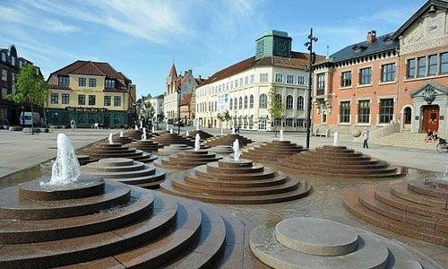
Working Methods

The working methods of “Climate Ambassador” come from the field of non-formal education, for us being very important that they are interactive and not formal or theoretical and rigid. Just like the schedule timeline shows, the following methods can be identified:

-name games (for improving communication)

-icebreaking games (for relaxing the group atmosphere and removing barriers created by shyness, hesitation and language)

-open space (to allow participants to think and act freely, to choose how and what to discuss)

-teambuilding activities (for the group cohesion, improving group work)

Who can participate in the youth exchange?
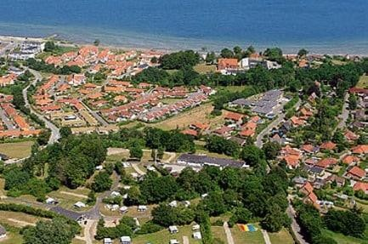
The young participants of “Climate Ambassadors” come from 5 countries with multiple cultural, religious and social differences, which contributes to the multicultural spirit of the project. The project team drafted a profile of the participant, according to:
GENERALITIES
-Age: between 15 and 30 years;
-Gender: we want an equal ratio of boys/girls;

-Education: most of the young people will be in the last years of high school, in the faculty / master and some will have the completed studies;
-Work experience: most of the young people are without a full-time job due to studies, but it is possible to have a percentage active in the labor market (part-time, freelancer); we have young people with reduced opportunities in the NEET category (who do not study and do not have a job).

THE VENUE
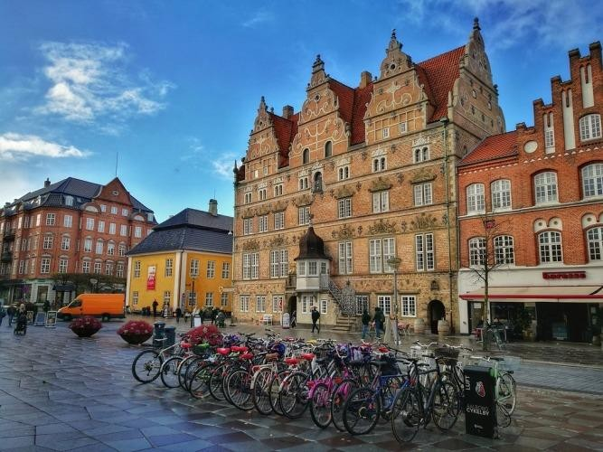

Note: Organisers will not provide accommodation for any additional stay in DENMARK. If participants plan to arrive a few days earlier or depart a few days later, they are kindly requested to inform us and we will be glad to offer assistance with booking a hotel

ACCOMMODATION PLACE

Mellerup Centret
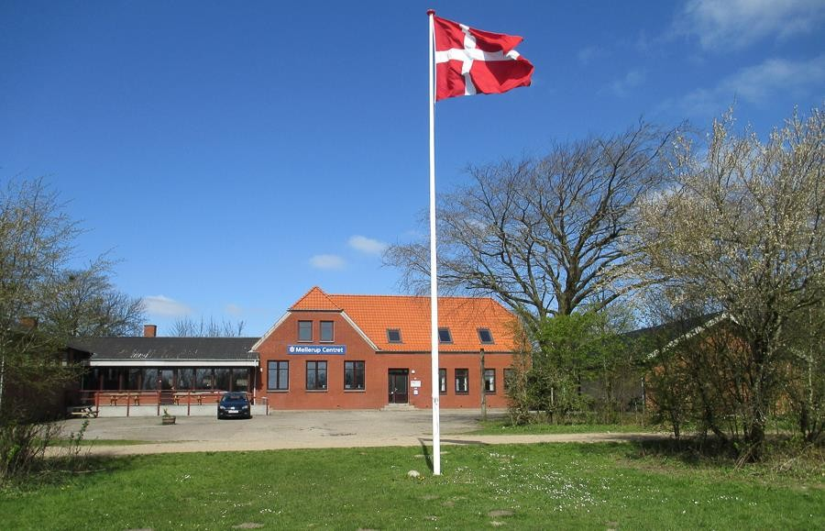
https://mellerupcentret.dk/

Rooms: The main activity room is located in the accommodation place. Wi-Fi internet connection is available. Organisers will provide participants with three meals per day.

Bring your personal stuff like towels etc…

We strongly recommend each participant to inform the organizers about any special dietary needs in advance.

HOW TO REACH THE LOCATION
You can fly to Copenhagen/Aalborg/Hamburg Airports. From all those places you can come to project venue by buss or train.
In case, we can pick you up from closed place like cities Rødekro/ Aabenraa by car or minibus.
From Copenhagen;
https://www.rome2rio.com/map/Copenhagen/H%C3%B8jset vej-25-6534-Agerskov-Denmark#r/Train
From Aalborg;
https://www.rome2rio.com/map/Aalborg/H%C3%B8jsetvej- 25-6534-Agerskov-Denmark
From Hamburg;
https://www.rome2rio.com/map/Hamburg-Airport- HAM/H%C3%B8jsetvej-25-6534-Agerskov-Denmark

WHAT TO BRING

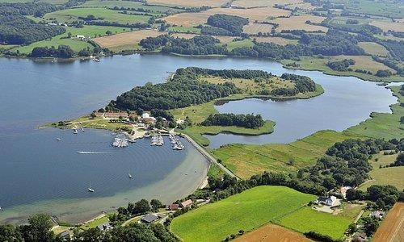

Since there is going to be an international evening, we will ask you to bring something traditional, famous or delicious from home - that you would like to represent your country with, and share with the others, it can be any kinds of food, drink...

HEALTH INSURANCE
Health insurance is not provided and will not be reimbursed by the organisers. All participants are strongly advised to purchase private travel insurance, as costs of private health care in Turkey are quite high if you don’t have.

The organizers will not provide the participants with any kind of insurance! Therefore, we
strongly recommend every participant to acquire travel insurance at their own expense for the whole duration of the course. Also, please have a valid EU healthcare insurance card (if applicable).

Each of the participating countries should;
- Bring all your travel documents as presented above. Print out all your documents even if they are online. We don’t have printing opportunities.
- Prepare a presentation about the sending organization (initiatives they have previously participated in, non-formal learning methods used, etc.). We want to get to know each other, to find out how people work with youth in other countries, and maybe to cooperate in the future.

Find interesting videos / games / exercises / educational activities on diversity.
- Prepare energisers that could be done in the morning.
- Prepare for your country’s cultural evening. Please, try to be fun and creative for this! :) No one likes regular .ppt presentations! Any kind of activities are welcome (e.g. video presentations, dances, songs, games, quizzes, posters, flyers etc.). Don’t forget to bring your national drinks, dishes or snacks to share with others
- check the weather forecast before arrival and bring adequate clothes. Please also bring clothing and shoes that can be used for strenuous activities (such as dancing).

Bring good spirit, joy and happiness!!!

Whenever possible, bring your laptops, digital cameras, smart phones and tablets – we will be doing some multimedia work that requires mobile equipment!

CONTACTS!

If you have any questions, please contact us

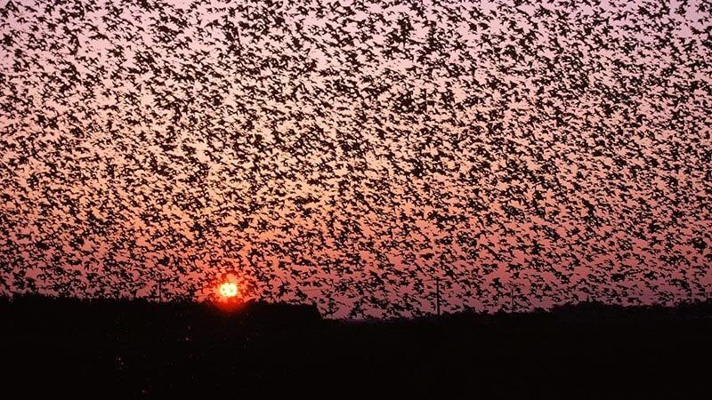

SEE YOU ALL IN DENMARK

